|  |  |
| --- | --- |
| **NAME:-** | Bodhisatya Ghosh |
| **UID:-** | 2021700026 |
| **BRANCH:-** | CSE DS |
| **BATCH:-** | B |
| **EXP. NO.:-** | 10 |

**AIM:** Cisco Packet Tracer.

**THEORY:**

**Packet Tracer** is a [cross-platform](https://en.wikipedia.org/wiki/Cross-platform) visual [simulation](https://en.wikipedia.org/wiki/Simulation) tool designed by [Cisco Systems](https://en.wikipedia.org/wiki/Cisco_Systems) that allows users to create [network topologies](https://en.wikipedia.org/wiki/Network_topologies) and imitate modern [computer networks](https://en.wikipedia.org/wiki/Computer_networks). The software allows users to simulate the configuration of Cisco routers and switches using a simulated command line interface. Packet Tracer makes use of a [drag and drop](https://en.wikipedia.org/wiki/Drag_and_drop) user interface, allowing users to add and remove simulated network devices as they see fit.

Let’s test a simulation.

**Topology Diagram:**

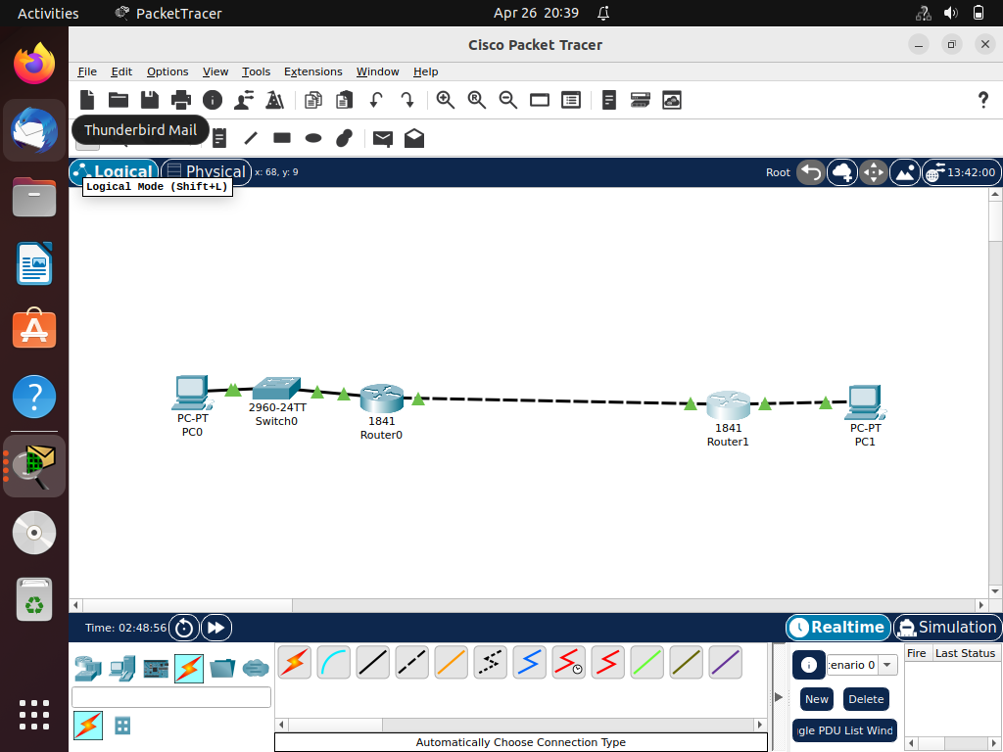

## Addressing Table:

|  |  |  |  |  |
| --- | --- | --- | --- | --- |
| **Device** | **Interface** | **IP Address** | **Subnet Mask** | **Default Gateway** |
| **R1** | Fa0/0 | 192.168.1.27 | 255.255.255.224 | N/A |
| Fa/0/1 | 192.168.1.40 | 255.255.255.224 | N/A |
| **R2** | Fa0/0 | 192.168.1.70 | 255.255.255.224 | N/A |
| Fa/0/1 | 192.168.1.42 | 255.255.255.224 | N/A |
| **PC1** | NIC | 192.168.1.10 | 255.255.255.224 | 192.168.1.40 |
| **PC2** | NIC | 192.168.1.87 | 255.255.255.224 | 192.168.1.70 |

## Learning Objectives

Upon completion of this lab, you will be able to:

* Subnet an address space given requirements.
* Assign appropriate addresses to interfaces and document.
* Configure and activate Serial and FastEthernet interfaces.
* Test and verify configurations.
* Reflect upon and document the network implementation.

## Scenario

In this lab activity, you will design and apply an IP addressing scheme for the topology shown in the Topology Diagram. You will be given one address block that you must subnet to provide a logical addressing scheme for the network. The routers will then be ready for interface address configuration according to your IP addressing scheme. When the configuration is complete, verify that the network is working properly.

Task 1: Subnet the Address Space.

Step 1: Examine the network requirements.

You have been given the 192.168.1.0/24 address space to use in your network design. The network consists of the following segments:

* The network connected to router R1 will require enough IP addresses to support 15 hosts.
* The network connected to router R2 will require enough IP addresses to support 30 hosts.
* The link between router R1 and router R2 will require IP addresses at each end of the link.

Step 2: Consider the following questions when creating your network design.

How many subnets are needed for this network? Ans. 3 subnets.

What is the subnet mask for this network in dotted decimal format? Ans. 255.255.255.224

What is the subnet mask for the network in slash format? Ans. /27

How many usable hosts are there per subnet? Ans. 30

Step 3: Assign subnetwork addresses to the Topology Diagram.

1. Assign subnet 1 to the network attached to R1. 192.168.1.0/27
2. Assign subnet 2 to the link between R1 and R2. 192.168.1.32/27
3. Assign subnet 3 to the network attached to R2. 192.168.1.64/27

Task 2: Determine Interface Addresses.

Step 1: Assign appropriate addresses to the device interfaces.

1. Assign the first valid host address in subnet 1 to the LAN interface on R1.

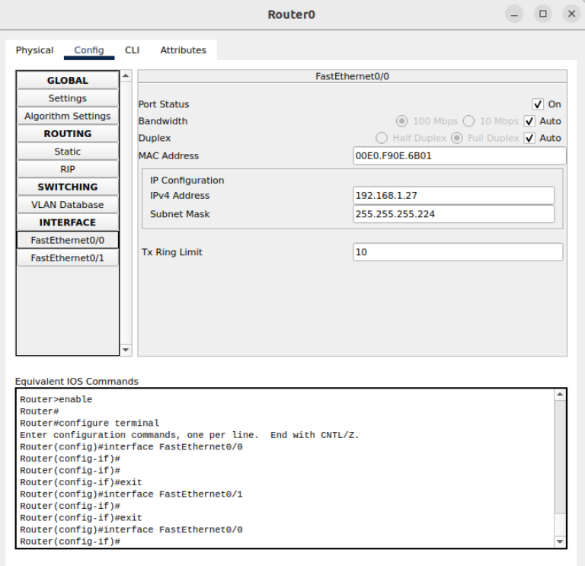

1. Assign the last valid host address in subnet 1 to PC1.

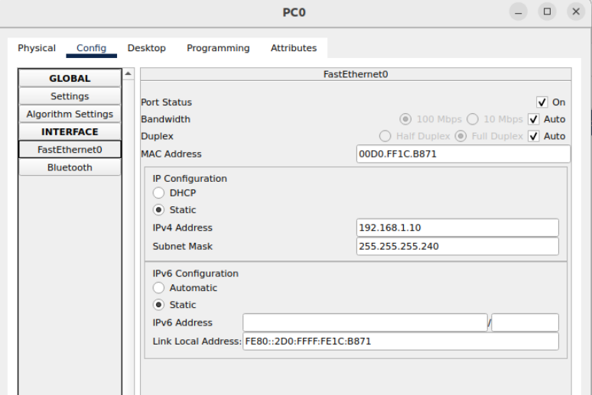

1. Assign the first valid host address in subnet 2 to the WAN interface on R1.

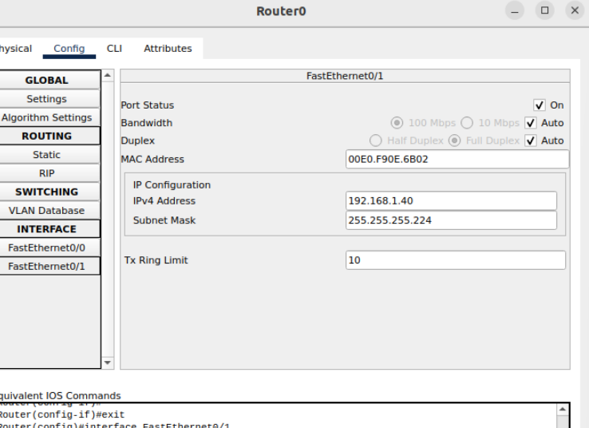

1. Assign the last valid host address in subnet 2 to the WAN interface on R2.

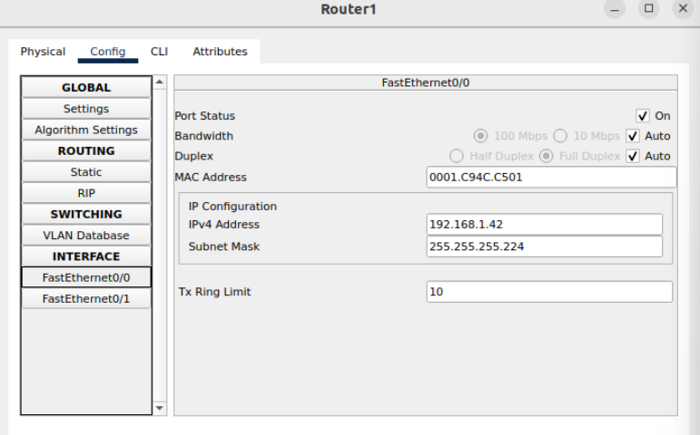

1. Assign the first valid host address in subnet 3 to the LAN interface of R2.

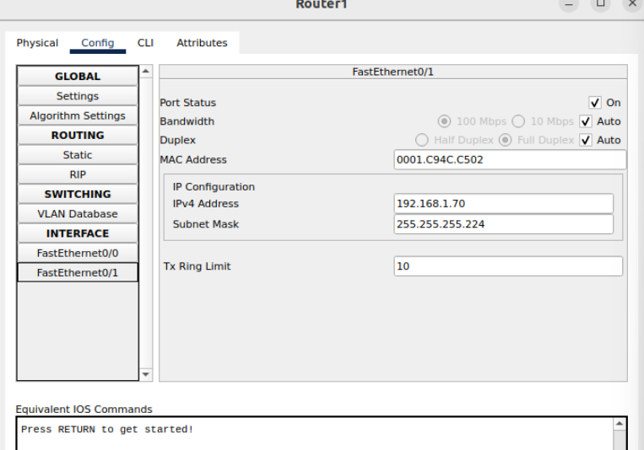

1. Assign the last valid host address in subnet 3 to PC2.

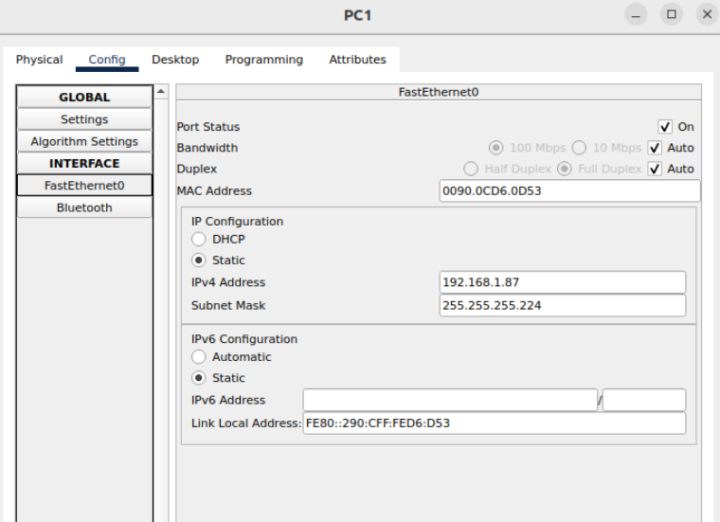

Step 2: Document the addresses to be used in the table provide under the Topology Diagram.

Done in the table itself.

Task 3: Configure the Serial and Fast Ethernet Addresses.

Step 1: Configure the router interfaces.

Configure the interfaces on the R1 and R2 routers with the IP addresses from your network design. Please note, to complete the activity in Packet Tracer you will be using the Config Tab. When you have finished, be sure to save the running configuration to the NVRAM of the router.

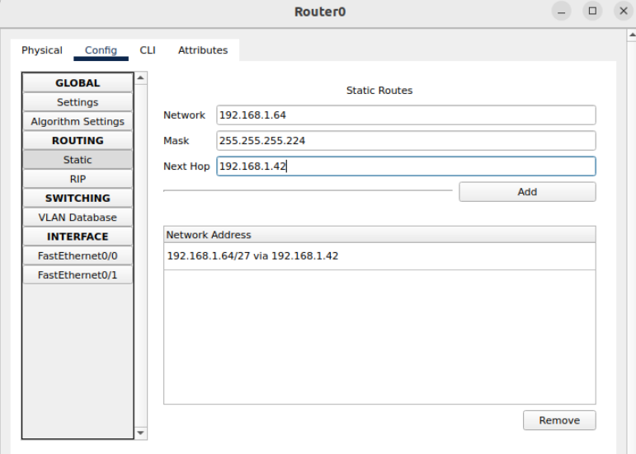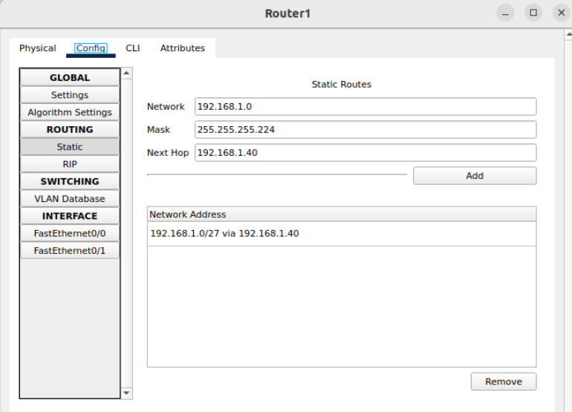

Step 2: Configure the PC interfaces.

Configure the Ethernet interfaces of PC1 and PC2 with the IP addresses and default gateways from your network design.



Task 4: Verify the Configurations.

Answer the following questions to verify that the network is operating as expected.

From the host attached to R1, is it possible to ping the default gateway? Yes

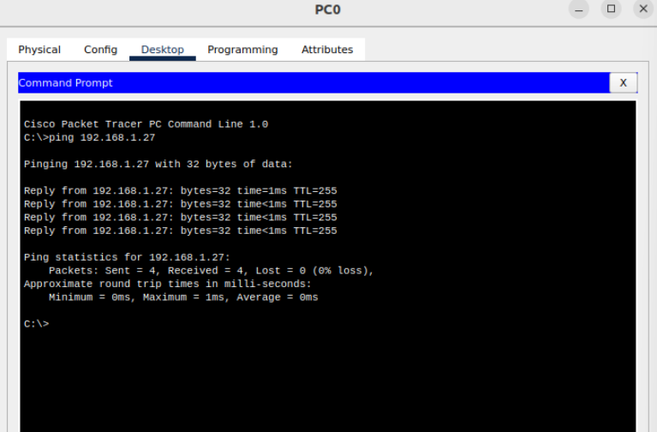

From the host attached to R2, is it possible to ping the default gateway? Yes

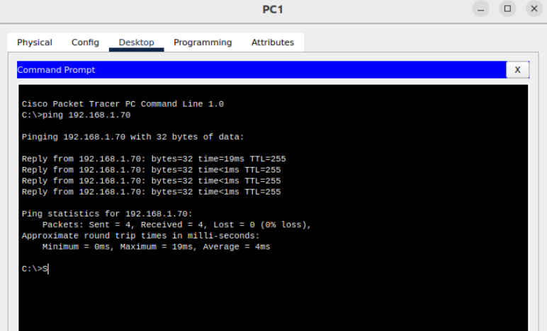

From the router R1, is it possible to ping the Serial 0/0/0(here the other Fa port) interface of R2? Yes

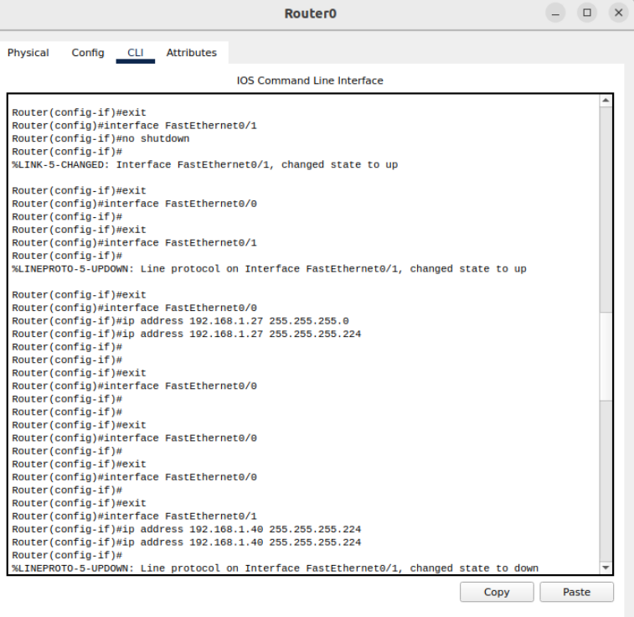

From the router R2, is it possible to ping the Serial 0/0/0(here the other Fa port) interface of R1? Yes

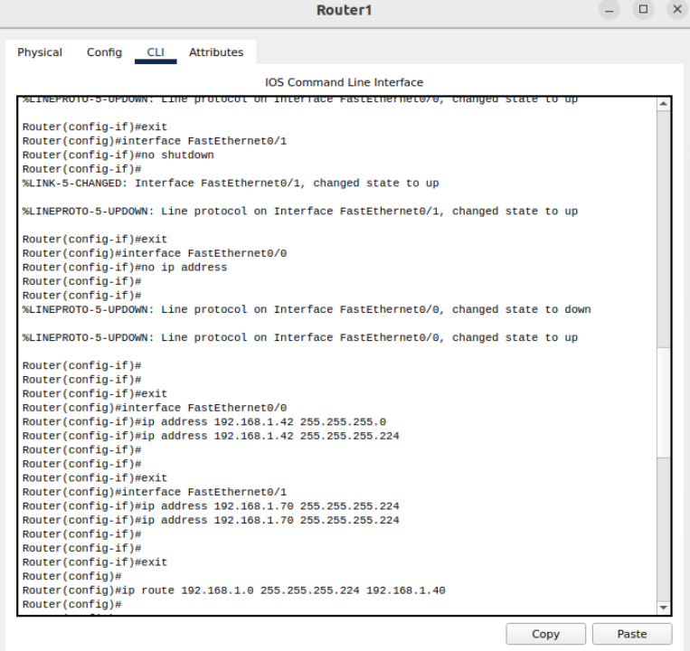

Task 5: Reflection

Are there any devices on the network that cannot ping each other?

🡪All the devices can ping each other.

What is missing from the network that is preventing communication between these devices?

🡪There is proper communication between the networks.

**CONCLUSION:** We saw how to install Cisco packet tracer and how to use it to simulate our network.